NAGVA Board Call
Meeting Minutes: 02/28/2018

- Roll Call – Jason F, Brian C, Lew S, Mark E, BJ, Andrew C, Jason P, Jen C, Rich S, Brian S, Jimmy S, Mark D
- Las Vegas Bid Presentation – Rick T and Brian C
  - Tonight’s presentation is just informative
  - We will have a call in two weeks to make decision
  - Q: Any plans on engaging locals A: No specific plans but know local players and is part of the plan. We’ll work with the LGBT person at the Visitor’s Bureau
- Officer/Department Reports
  - President
    - Attended the Connect Diversity conference in Portland, OR
    - Connected with 36 different Visitor’s Bureaus and Sports Commissions
    - This will allow us to identify places for Championships in the future
  - Vice President
    - Reaching out to the MALs about the Hall of Fame next week
    - Soliciting board information about arrival and departure dates
  - Secretary
    - Deadline for amendment proposals has passed
    - Received 20 proposals
    - Help promote Spirit Award and Hall of Fame nominations
  - Treasurer
    - Financials:
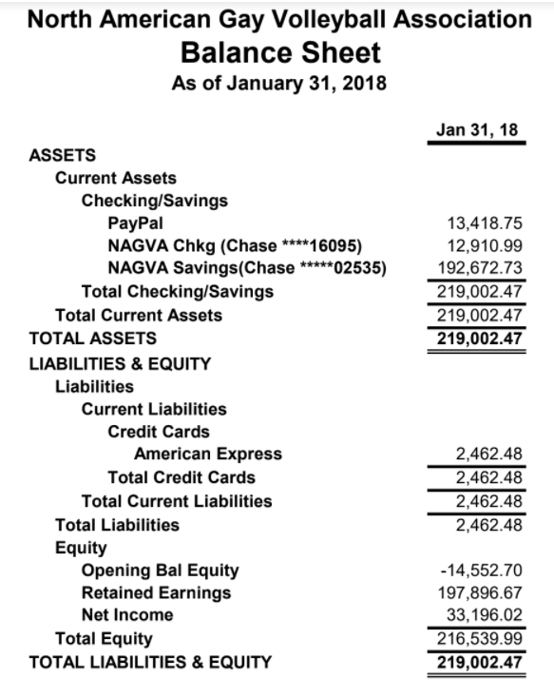
    - Chase – discussed options about our accounts, possibly moved away from PayPal and migrating to ChasePay as our primary payment receptacle
    - Q: Have we looked at using Zelle instead of PayPal A: Will have to look more into it
  - Registrar
  - Technology
  - Eligibility
    - January, 2018
      - Medical Re-Rate: 5 received; 1 granted, 4 denied
      - 3 Year Inactive Re-Rate: 7 received; 7 granted
    - February, 2018
      - Medical Re-Rate: 3 received; 1 granted, 2 denied
      - 3 Year Inactive Re-Rate: 12 received; 12 granted
      - Re-Rate Protest/Appeal: 1 received, 1 granted
  - Regions
    - Regions Report: November through February
      - # of Tournaments: 11 tournaments
      - # of Nonrates: 530
      - # of Rerates: 124 (47% uprates, 42% same, 6.5% downrate)
      - Total # of RCs Utilized: 19 RCs (Sacramento, DC, Vegas, Nola, St. Louis - all had multiple RCs) - 9/11 tournaments had RCs out of region.
    - You can always check out running totals from the spreadsheet in the Google Drive
  - Tournaments
    - Summer tournaments are up on the website. Registration for them will open April 1st.
    - Oklahoma is a new addition to our tournaments: Sammy Duncan is running the tournament
    - Wisconsin Dells is moving to Madison
    - Q: Did you receive the Vancouver Insurance receipt? A: Believes it came in today
  - Officials
    - Working with the Officials Chairperson in Minneapolis.
    - Want to Jr. National and National Officials only if possible
  - Communications
  - Canadian Representative
    - Only 135 Canadian players
    - Will have breakdown of what the average Canadian player looks like for the board at the end of the year meeting
- MAL Reports
  - Trevor
  - Rich
  - Brian
    - Reached out to 50 NAGVA players across the country
      - Fall tournaments – happy with their calendar distribution
      - Spring tournaments – feel they are a little cramped
      - Potential of moving Championships – allows for Championships to be bigger
      - Thoughts on open format at Championships
        - AA players seemed ok with it
        - A players – seemed concerned but possibly not understanding the format
      - Board members need make more of a concerted effort to introduce themselves to members
  - Jimmy
- Championships Update
  - Hotel Update – fixed the error in the reservation system. Teams can now reserve more than one room
  - NAGVA Serves – still looking for a service project
  - Fundraising Update
- New Business
  - Open A/AA Division at Championships
    - Discussion was held on what format the Open A/AA Division will take.
      - Many possibilities were discussed
      - Question was posed in an email to continue discussion and vote will be held tomorrow.
    - Motion: Mark - Unrated players will be treated as AA players. Vote - Unanimous
  - Discussion about appropriateness of team names and t-shirt.
    - Mark E suggested to make that a discussion topic for the end of the year meeting.
    - No objections so topic was tabled until the May meeting.
- Meeting Adjourns

